**What is a public IP address?**

A public IP address is an IP address that can be accessed directly over the internet and is assigned to your network router by your internet service provider (ISP). Your personal device also has a private IP that remains hidden when you connect to the internet through your router’s public IP.

**What is a private IP address?**

A private IP address is an address your network router assigns to your device. Each device within the same network is assigned a unique private IP address (sometimes called a private network address) — this is how devices on the same internal network talk to each other.

**Public and private IP address ranges**

Your private IP address exists within specific private IP address ranges reserved by the Internet Assigned Numbers Authority (IANA) and should never appear on the internet. There are millions of private networks across the globe, all of which include devices assigned private IP addresses within these ranges:

Class A: 10.0.0.0 — 10.255.255.255

Class B: 172.16.0.0 — 172.31.255.255

Class C: 192.168.0.0 — 192.168.255.255

These might not seem like wide ranges, but they don’t really need to be. Because these IP addresses are reserved for private network use only, they can be reused on different private networks all over the world — without consequence or confusion.

And don’t be surprised if you have a device or two at home with a so-called 192 IP address, or a private IP address beginning with 192.168. This is the most common default private IP address format assigned to network routers around the globe.

Unsurprisingly, the public IP address range encompasses every number not reserved for the private IP range. Since a public IP address is a unique identifier for each device connected to the internet, it needs to be just that: unique.

**NAT (Network Address Translation)**

NAT translates the IP addresses of computers in a local network to a single IP address. This address is often used by the router that connects the computers to the Internet.

**Types:**

1. Static Translation (1 to 1)
2. Port Address Translation (1 o 1) Port 80
3. NAT overload Translation (PAT)
4. Dynamic Translation (NAT Pool)

Here, Static – 1 & 2 and Dynamic – 3 & 4

**1. Static Translation (1 to 1)**

Before configuring the NAT protocol, we must implement any routing protocol like RIP, OSPF, etc.

In Static NAT, a one-to-one mapping is created between a private IP address and a public IP address. This is commonly used when a device on a private network needs to be accessed from the public Internet, such as a web server or email server.

**Configuring Router7:**

* int gig0/0
* ip nat out
* int gig0/1
* ip nat inside
* ip nat inside source static 10.0.0.240 (private ip) 209.165.100.29 (public ip)

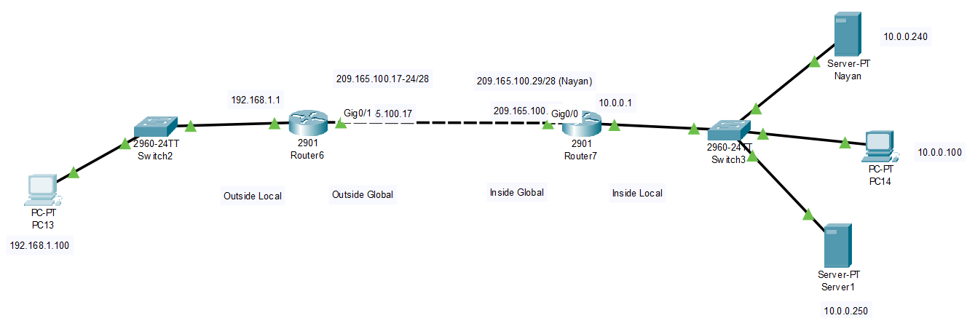

Now if you search 209.165.100.29 from PC13 (192.168.1.100) then you will reach to Server-PT (Nayan) (10.0.0.240).

[**router7# show ip nat translation**]

* When you configure "ip nat out" on an interface in a Cisco router, it enables NAT for all outgoing packets from that interface.
* The GigabitEthernet0/0 interface is facing the public Internet, and is configured as "ip nat outside".
* The GigabitEthernet0/1 interface is facing the internal network, and is configured as "ip nat inside".
* The "ip nat inside source" command specifies that NAT should be applied to packets coming from the inside network (GigabitEthernet0/1) and going to the outside network (GigabitEthernet0/0).

**2. Port Address Translation (1 to 1) Port 80**

**Configuring Router7:**

* ip nat inside source static tcp 10.0.0.250 80 (private ip & port) 209.165.100.30 80 (public ip & port)

Now if you search 209.165.100.30 from PC13 (192.168.1.100) then you will reach to Server1 (10.0.0.250).

[router7# show ip nat translation]

* The command you provided is configuring a static NAT translation from an internal IP address of 10.0.0.250 on port 80 to an external IP address of 209.165.100.30 on port 80.

**3. NAT overload Translation (PAT)**

What if you have 10 PC on the 10.0.0.0 network?

You can use a single public IP or a pool of IPs to interact with the outside world. To use a single public IP (interface gig0/0 = 209.165.100.30),

**Configuring Router7:**

* access-list 10 permit 10.0.0.0 0.255.255.255 (wild card)
* ip nat inside source list 10 interface gig0/0 overload

[router7# show ip nat translation]

You can see that the inside local and inside global are different. But the outside local and outside global are the same because we didn’t apply nat in router6. So we need to apply nat in router6.

**4. Dynamic Address Translation (NAT Pool)**

**Configuring Router6:**

* int gig0/1
* ip nat outside
* int gig0/0
* ip nat inside
* access-list 1 permit 192.168.1.0 0.0.0.255
* ip nat pool MYPOOL 209.165.100.17 209.165.100.24 netmask 255.255.255.240
* ip nat inside source list 1 pool MYPOOL overload

[router6# show ip nat translation]

(If you want to delete all nat entries: clear ip nat translation *)

**Access List**

What if you have 10 PC on the 10.0.0.0 network?

You can use a single public IP.

**IP nat inside source (Normal NAT for Internet)**

o Translates the **source** of the IP packets when traveling from **inside to outside**

o Translates the **destination** of the IP packets when traveling from **outside to inside**

**IP nat outside source (Useful for overlapping subnets)**

o Translates the **source** of the IP packets when traveling from **outside to inside**

o Translates the **destination** of the IP packets when traveling **inside to outside**

**Configuration**

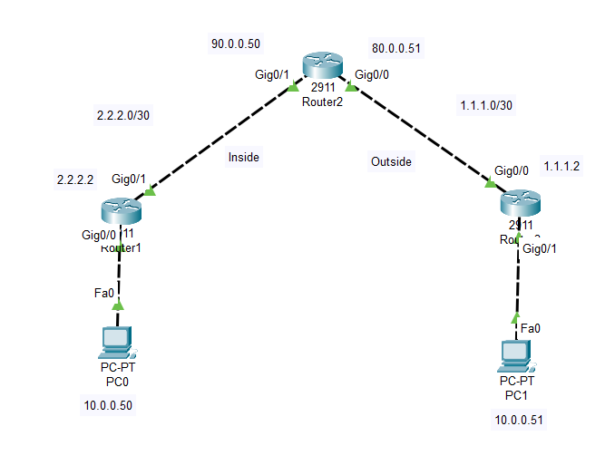

**Nat inside and outside in Router2:**

ip nat outside (gig0/0)

ip nat inside (gig0/1)

ip nat inside source static 10.0.0.50 90.0.0.50

ip nat outside source static 10.0.0.51 80.0.0.51

**Static routing for Router 2:**

ip route 80.0.0.51 255.255.255.255 1.1.1.2

ip route 10.0.0.50 255.255.255.255 2.2.2.2

**Static routing Router 1:**

ip route 80.0.0.51 255.255.255.255 2.2.2.1

**Static routing Router 3:**

ip route 90.0.0.50 255.255.255.255 1.1.1.1

**To show which commands are given:**

* Show run | i nat
* Show run | i route

**To debug:**

On router: debug ip nat

From PC: ping -n 1 11.0.0.51 (single packet send)

Another configuration:

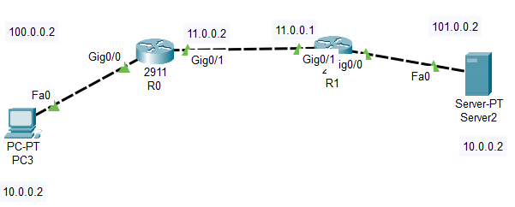

**Nat inside in R0:**

ip nat inside (gig0/0)

ip nat outside (gig0/1)

ip nat inside source static 10.0.0.2 100.0.0.2

**Nat inside in R1:**

ip nat inside (gig0/0)

ip nat outside (gig0/1)

ip nat inside source static 10.0.0.2 101.0.0.2

**Static routing in R0:**

ip route 101.0.0.2 255.255.255.255 11.0.0.1

**Static routing in R1:**

ip route 100.0.0.2 255.255.255.255 11.0.0.2